Transgender issues are more complicated than some Christians portray

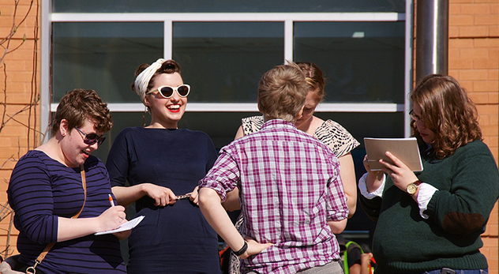
Since he was a baby, Kris, now 26-years-old, knew he was a boy stuck in a girl’s body.
“I have never not known that I was a boy or supposed to be a boy,” he says, “but I’ve only been able to express it in words for the last six to 10 years.”
Kris’s parents recently joined the church I attend, which is how we became friends. Every few weeks, we meet at a coffee shop near my house for a couple of mocha shakers and rich conversation. Like me, Kris was raised in a conservative evangelical home, and we almost always end up talking about faith when we meet. But it’s a sore subject for him.
“My experience as a transgender person growing up in the church was damaging,” he says. “I didn’t feel safe talking to my parents or my pastor about it. I felt like if I told anybody that I wanted to be a boy, things were going to go badly. Rather than talk about it, I prayed every night: ‘Please God, make me a boy.’”
Two weeks ago, Kris legally changed his name. Three and a half months ago, he started testosterone hormone therapy. Kris’s voice grows deeper each time we talk. He says the next step for him is to have a bilateral mastectomy or “top surgery.” The doctor also suggests a hysterectomy because it is believed the testosterone therapy can otherwise increase his chance of cancer.
When it comes to future relationships, Kris says he has no immediate plans to find a mate: “I’m fairly asexual, and though I do have a sex drive, I’m not pursuing a romantic or sexual partner. It’s just not a priority for me.”
Transgender people like Kris have increasingly become a topic of conversation among conservative Christians. Christian television personality Pat Robertson really commented about transgender people on his “700 Club” show, saying, “I think there are men who are in a woman’s body … I don’t think there’s any sin associated with that.” Liberals praised Robertson, while some Christians criticized him. The issue was brought to the fore again when California Gov. Jerry Brown signed into law a bill letting transgender students choose which restroom they would use and whether they would compete in boy or girl sports.
These events and others led some Christian leaders to speak out against the increased sensitivity to transgender people. An article by Russell Moore at the “On Faith” forum hosted by The Washington Post, for example, argued that transgender people are essentially confused. He urged churches to teach that “our maleness and femaleness points us to an even deeper reality, to the unity and complementarity of Christ and the church.”
Moore is someone for whom I have deep respect, and I appreciate his attempts to speak to this topic more compassionately than some of his Christian colleagues. Yet the issue seems to be more complicated than he and others are portraying.
Most conservative Christian’s arguments are rooted in Genesis 5:2: “[God] created them male and female.” This view states that one must be a certain way because one was born a certain way. If God makes humans with bodies of a particular gender, the argument goes, God did so intentionally.
The argument sounds pretty convincing at first glance–who are we to change what God has ordained?–but not all the facts are being considered. For example, there is no mention of intersex people, which are those persons who have physical and genetic variations that do not allow them to be strictly designated as either male or female.
According to research conducted by Anne Fausto-Sterling of Brown University, one in 100 children are born with “bodies that differ from standard male or female” biology. This includes those children born with both a penis and a vagina, as well as those with vaginal agenesis, ovatestes, or genetic disorders such as Klinefelter syndrome. Apparently, God sometimes creates humans both male and female or neither fully male nor fully female.
Intersex persons offer a critique of those who believe that gender is a static binary assigned from birth and divinely ordained. For example, what about a person who is a sexually “mosaic,” which means they have mixed gonadal dysgenesis such as the development of both ovaries and testes? It’s hard to say because Christian commentators almost never acknowledge the existence of these individuals.
When I asked Russell Moore about why he left what I believe is a significant part of the discussion out of his article, he said he doesn’t believe the existence of intersex persons is relevant to the discussion. “The substantial reason is that the question of ‘intersex’ is a question of epistemology, not of ontology,” he says. “It is of knowing whether someone is male or female, not about whether those categories pertain.” Additionally, he says, “only a minuscule number of cases involve persons of indeterminate gender.”
But the situation seems to grow even more complex when one considers the internal workings of transgender people. According to research conducted by the National University of Distance Education in Madrid, Spain, transgendered people show significant differences in brain patterns. MRI scans of female-to-male transgender people, for example, resembled male brain function even though they were born biologically female.
Christians believe that God not only creates our bodies, but also our minds. Are one’s external created realities more revealing about God’s intentions than one’s internal created realities?
I suspect many Christians are like me and haven’t considered all the theological, ethical, and scientific intricacies of this issue. Perhaps we are afraid that what we discover will stretch the bounds of our thinking. My unsettled thoughts about how to reconcile Kris’s gender identification with my Christian faith tempt me to shrink back from my friendship with Kris. And yet, I’m so glad I haven’t. Our conversations challenge my thinking and force me to ask new and difficult questions of myself. Kris and I may not end up agreeing on everything, but we press on in our friendship anyway. And I think we’re both better for it.
The transgender issue is an important one and Christians must grapple with it in all its messiness and complexity. So let’s not pretend that any armchair theologian should be able to figure it out. Kris deserves better. And so do all of our transgender neighbors.

- See more at: http://jonathanmerritt.religionnews.com/2013/08/19/transgender-issues-more-complicated-than-some-christians-portray/#sthash.vwDTqzz8.dpuf

